Circuit Inquiry


Purpose: Determine the basics of how a circuit works and discover the relationships between circuit elements.

Directions: Google “PHET Circuit Construction Kit: DC” or scan the QR code to the right to access the simulator.
Answer each of the following questions in as much detail as possible. Start in the “Intro” section of the simulator.

Part 1: Exploration
- For each of the circuit elements that can be found on the left-hand side of the simulator, describe them and explain what you think each of them are for.
Circuit Element | Description | Purpose
Wire
Battery
Light Bulb
Switch
Fuse
Resistor
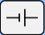
- Underneath the lefthand panel, select the symbol that looks like this:
Draw in the symbol for each circuit element.
Wire | Battery | Light Bulb | Switch | Fuse | Resistor
  - What do you notice about the symbols for the other items (coin, dog, hand, etc.), and why do you think this is the case?

Part 2: Building a Circuit
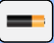
Switch the circuit elements back to lifelike representations by clicking this button:

- What do you think the blue circles represent?

- Select a wire. What can you change about the wire?

- Select a battery. What can you change about the battery?

- Select a light bulb. What can you change about the light bulb?

- Select a resistor. What can you change about the resistor?

- Drag and drop elements onto the workspace and connect them together to make a working circuit. How do you know that the circuit is working?

- What conditions must be true for the electrons to move?

- Draw a schematic of your working circuit below:
- What could you change about your circuit and still get it to work?

Part 3: Identifying Relationships
Create a circuit like the one shown below:
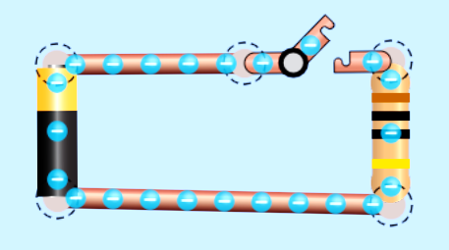

- Which direction do the blue circles flow around the circuit?

- Why do they flow in that direction?

- Prediction - How will changing the resistance affect their flow?

- Prediction - How will changing the voltage affect their flow?

- Based on your observations, what do you think each of the following measures
  - Current –

  - Voltage –

  - Resistance –

Using the ammeter record how a change in voltage or resistance affects the current flowing through the circuit. Then graph the relationship. For each data set, choose a fixed value for your constant variable and record it.

Data Set 1 – Voltage vs. Current

Constant Variable: Resistance = __________
Voltage  Units:________ | Current  Units:________

Graph:

Describe the patterns and relationships that you see in your data table and graph.

Data Set 2 – Resistance vs. Current
Constant Variable: Voltage = __________
Resistance  Units: ________ | Current  Units: ________

Graph:

Describe the patterns and relationships that you see in your data table and graph.

